Spatial Visualization

**QGIS Tutorial**

**1. Set up QGIS Environment**

Go to <https://qgis.org/en/site/forusers/download.html>

Download version 3.4.9 (require Python Version >= 3.6.5)

Following the guide to install the QGIS

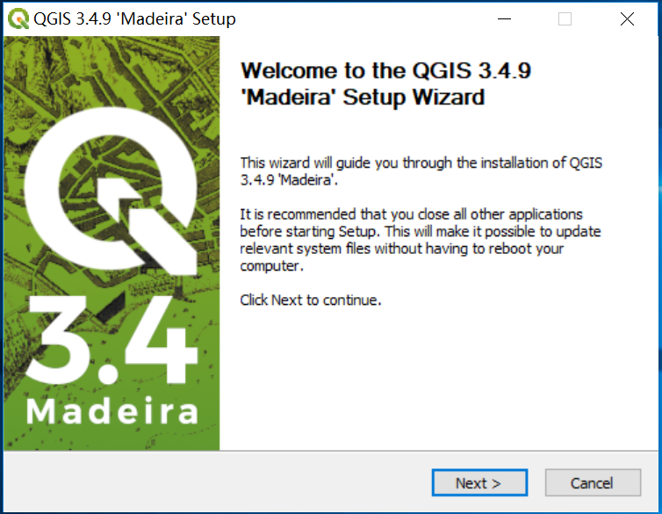

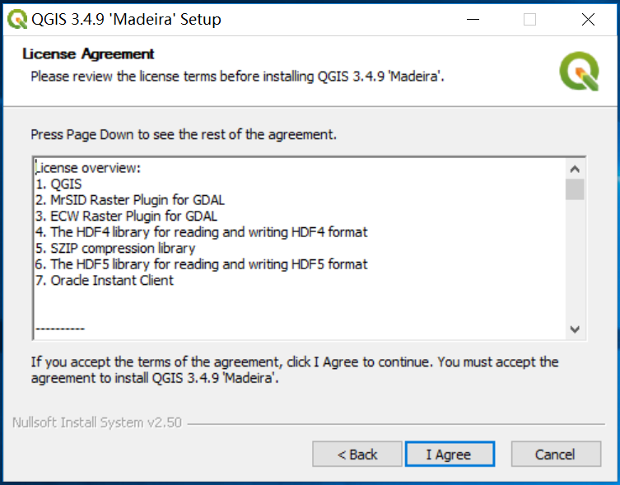

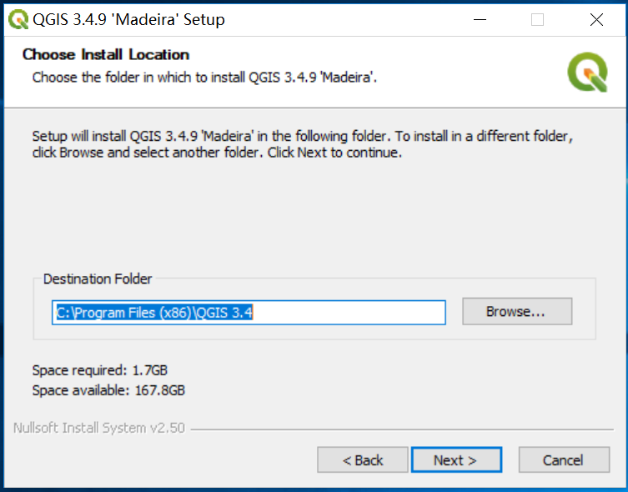

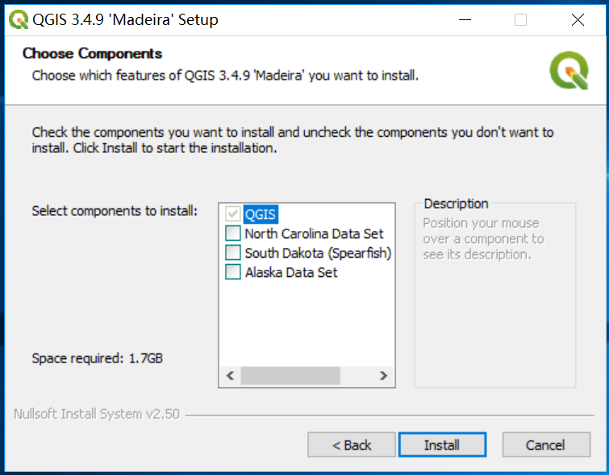

**2. Install Plugins**

Use OpenStreetMap as the **Base Map** to show the locations (see the below figure)

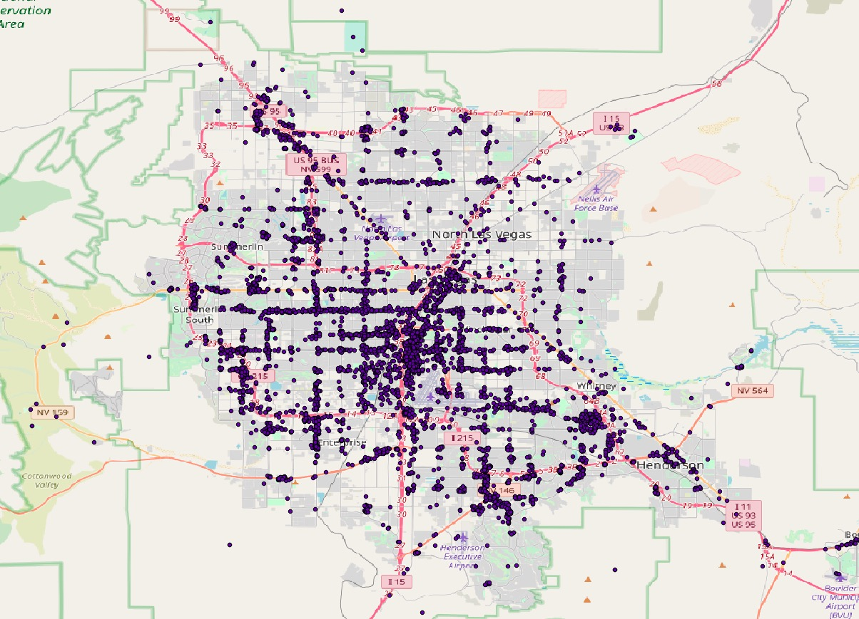

Go to [**Plugins**] => [**Manage and Install Plugins...**] => Search for **“QuickMapServices”** and Install

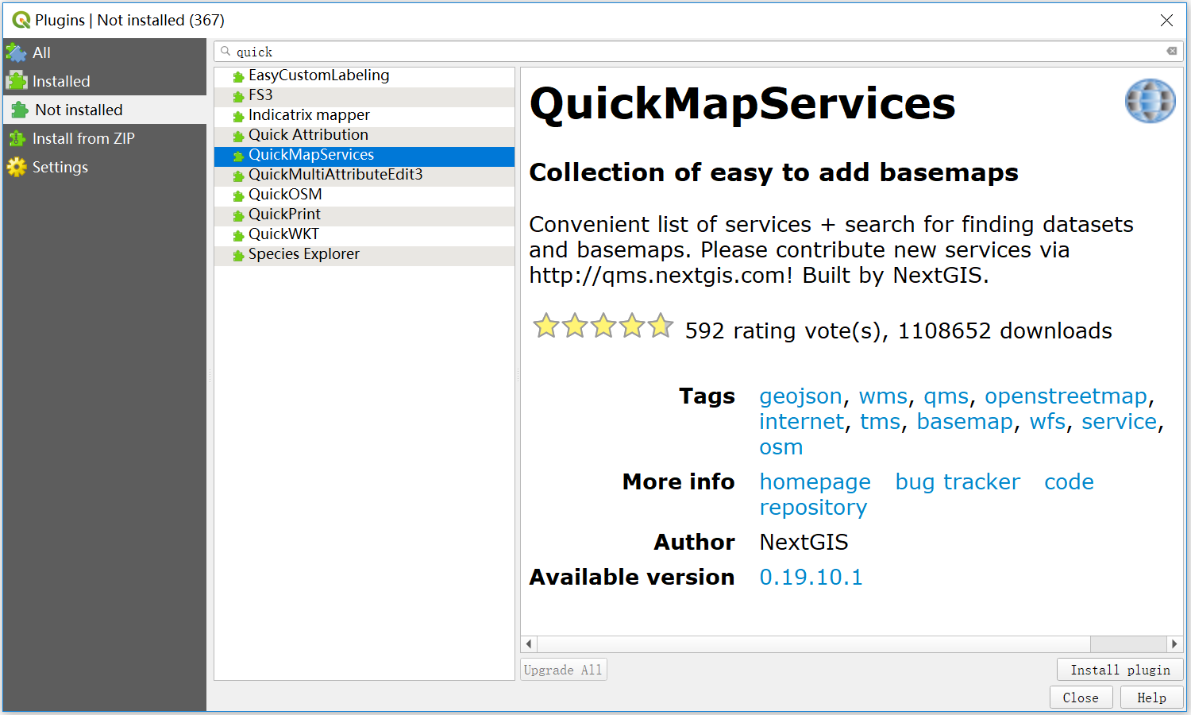

Go to [**Web**] => [**QuickMapServices**] => [**OSM**] => [**OSM Standard**]

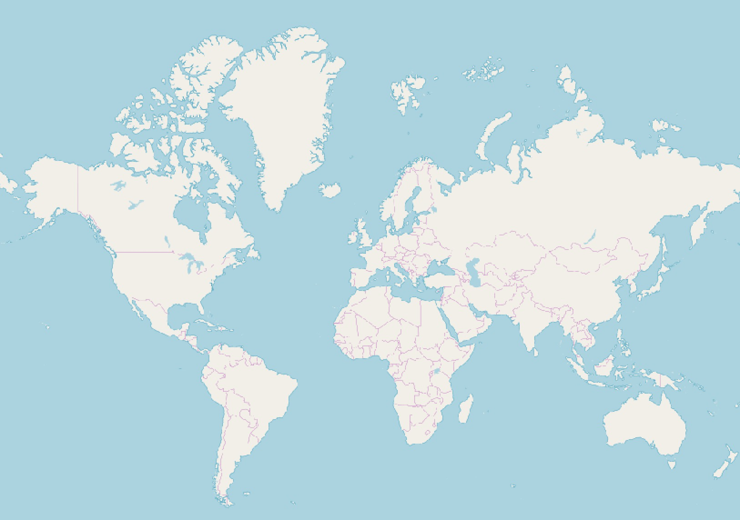

**3. Add Shapefile Layer**

a. Download the census tract data for Nevada State:

<https://catalog.data.gov/dataset/tiger-line-shapefile-2018-state-nevada-current-census-tract-state-based>

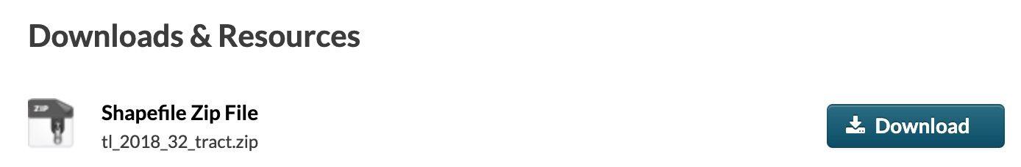

b. Directly drag the shapefile “tl_2018_32_tract.shp” to the Layer Panel

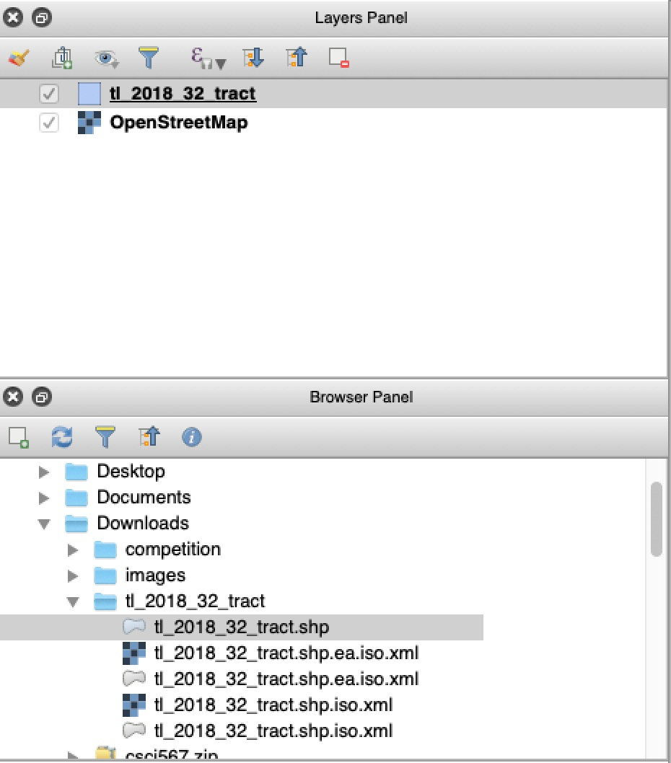

c. Right click the layer [**Zoom to layer**]

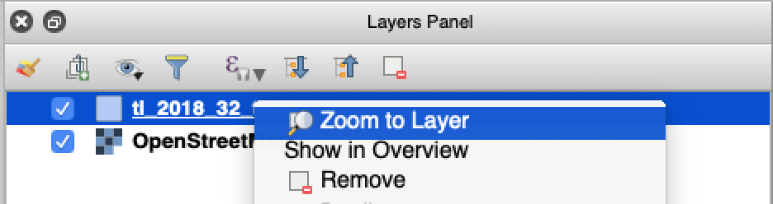

d. Right click the layer [**Properties**] => change the color and opacity

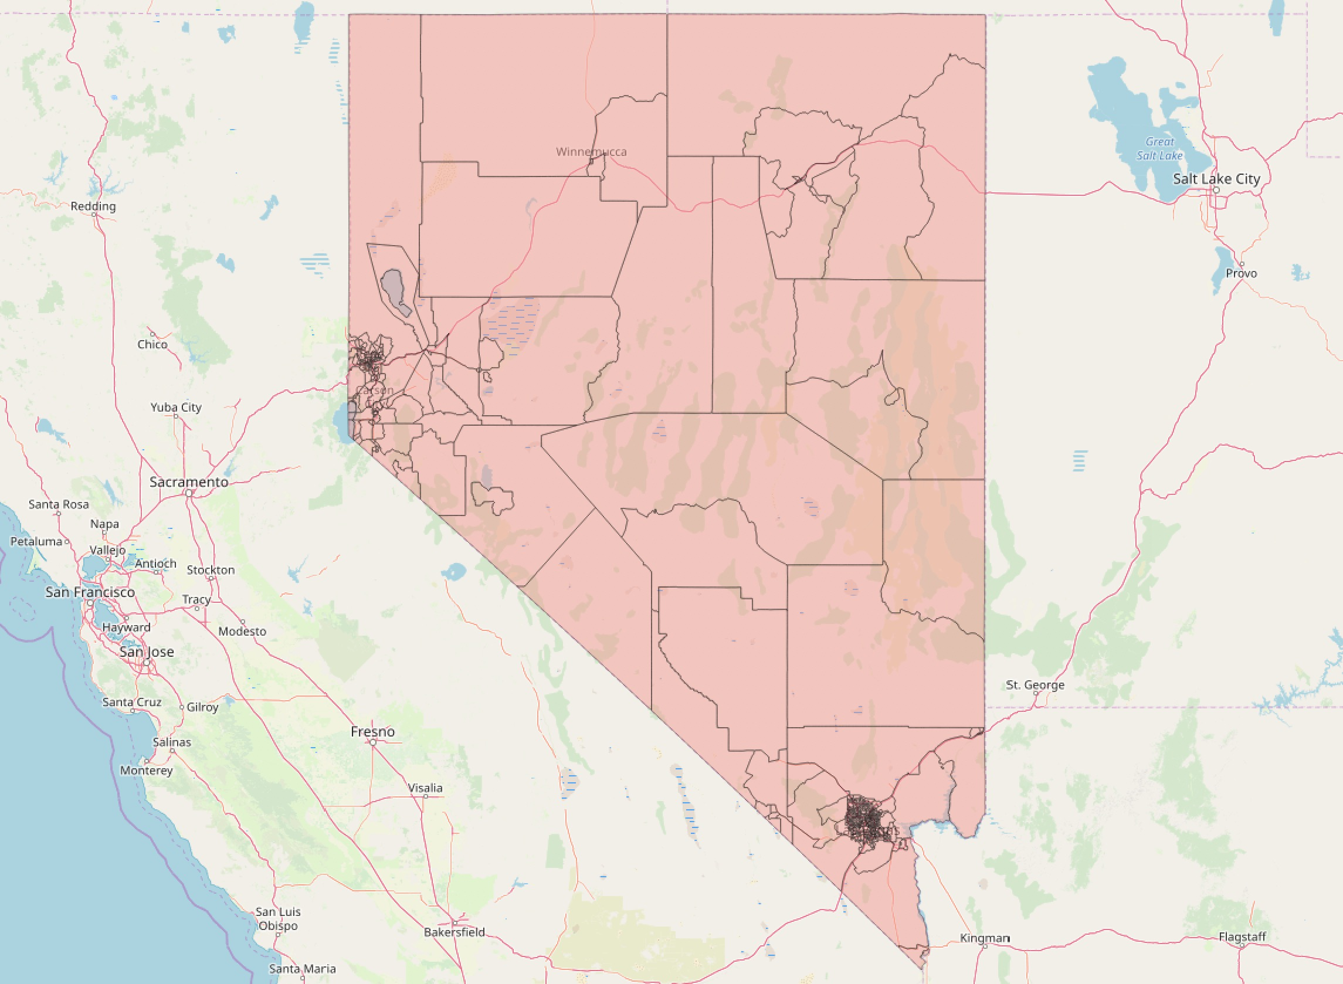

**4. Add Delimited Text Layer**

a. Add the CSV file containing the coordinates of the business locations

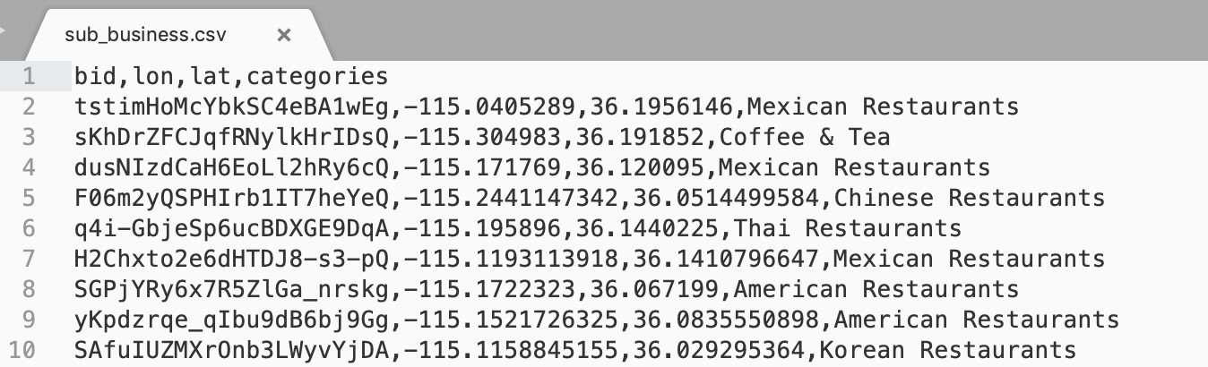

b. Open [**Data Source Manager**] => Load the file

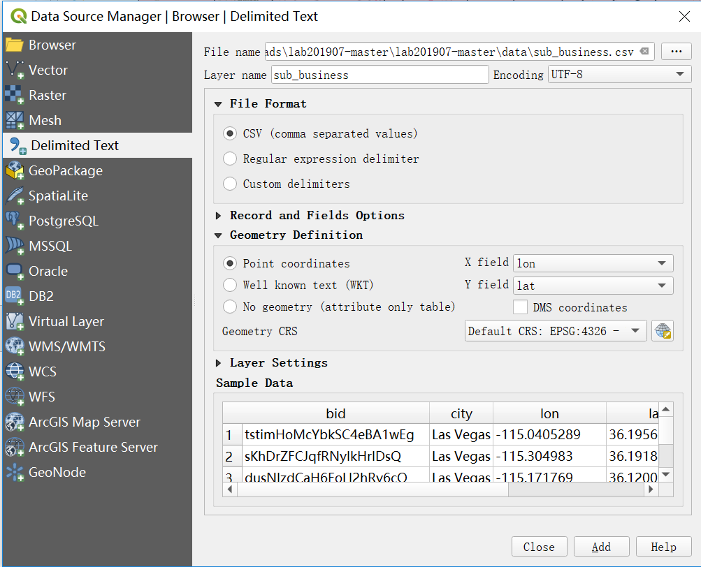

c. Zoom to the layer and change the properties

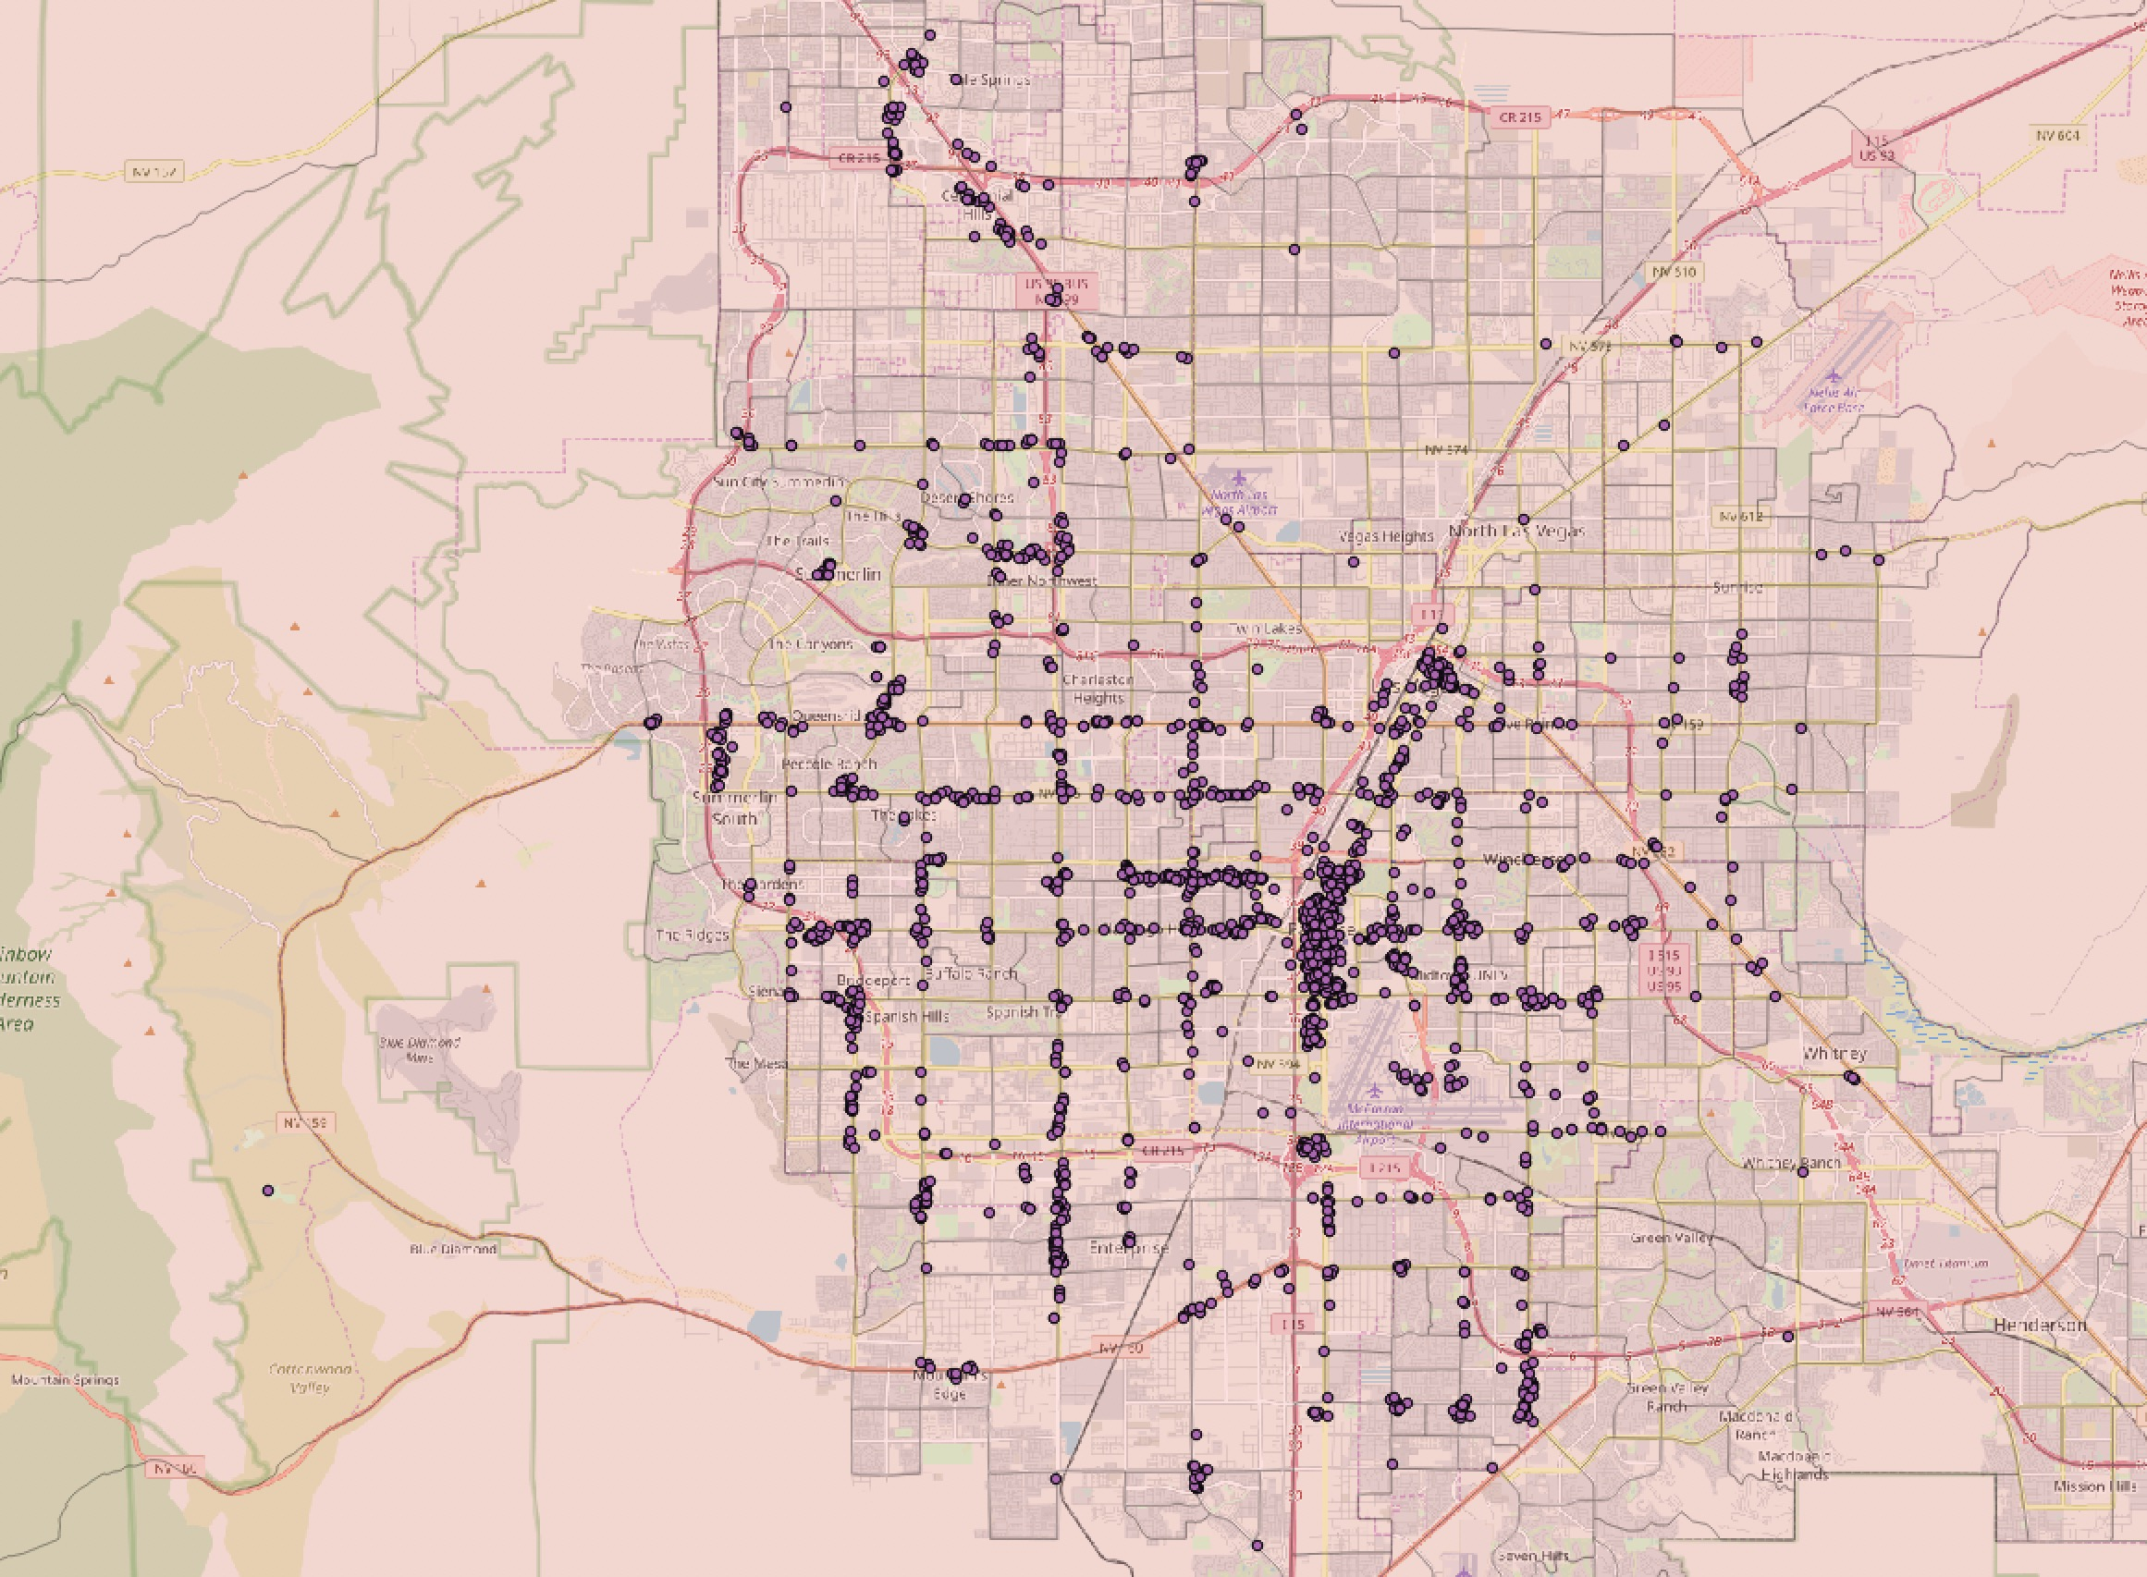

d. Right click the layer [**Open Attribute Table**] to view the data

**5. Generate New Tract Layer Using Spatial join**

Goal - Filter out the tracts that do not contain the business locations

a. Go to [Vector] => [Data Management Tools] => [Join attributes by locations]

**Target Layer that will keep in the joint result**

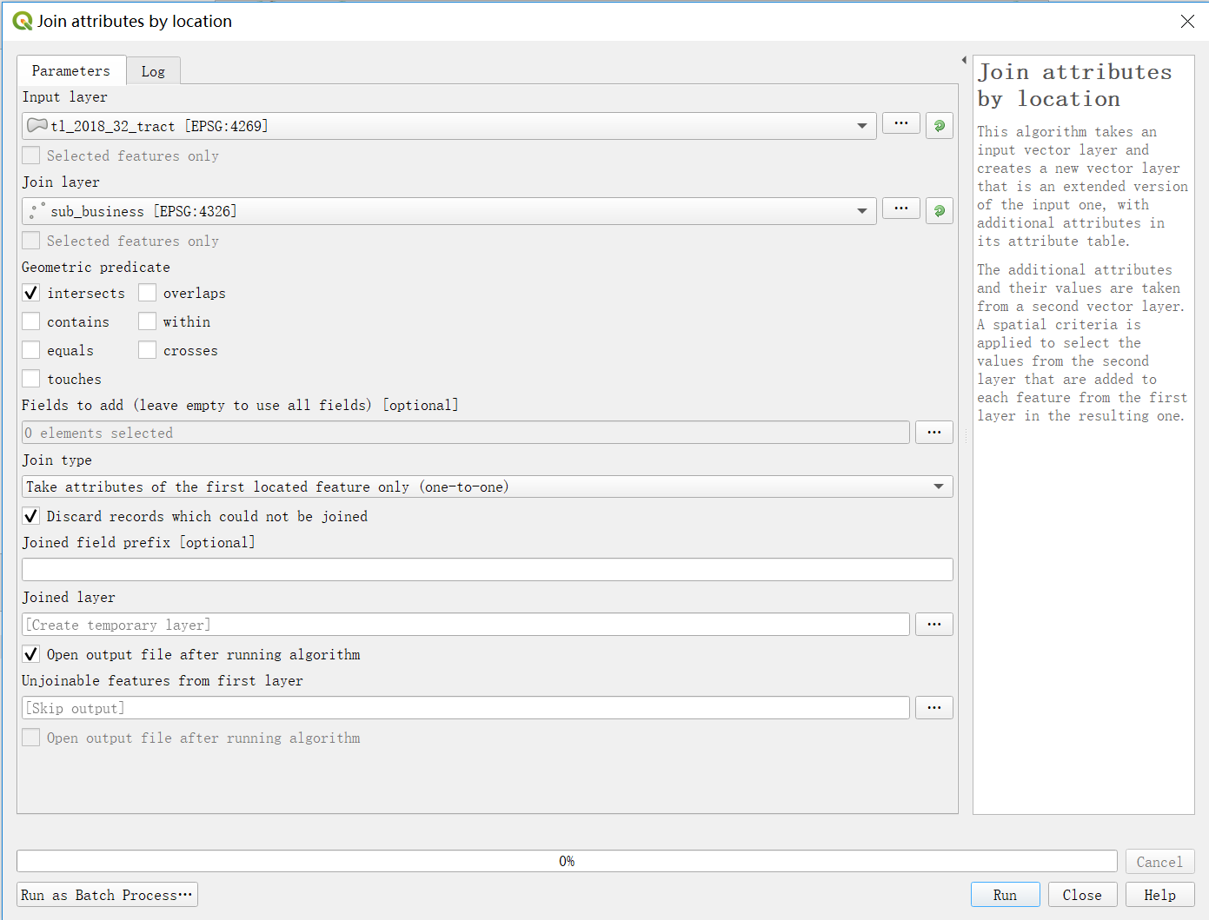

b. Zoom to the layer and change the properties

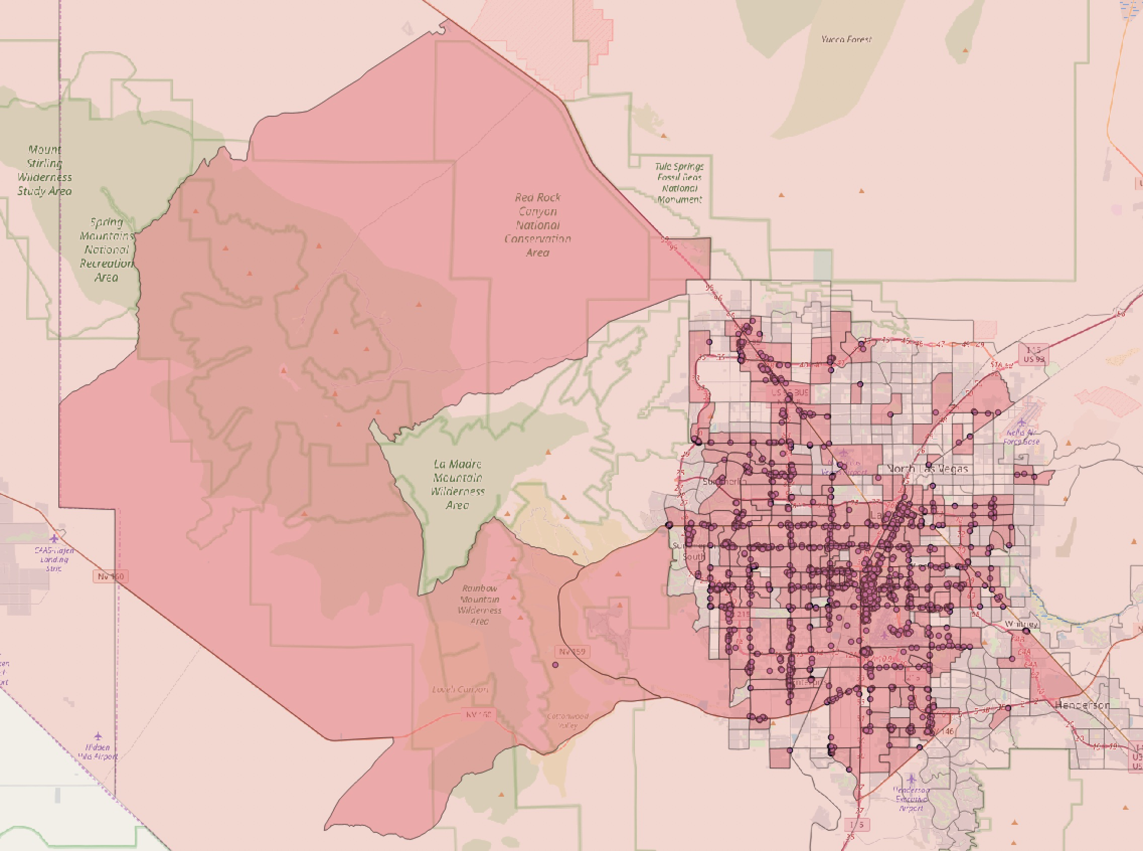

c. Filter out the polygon with the business location that is far from others

View the attribute of that polygon => GEOID = 32003007500

Right click the joined layer => [**Filter**] => Add filter expression [**"GEOID” != 32003007500**]

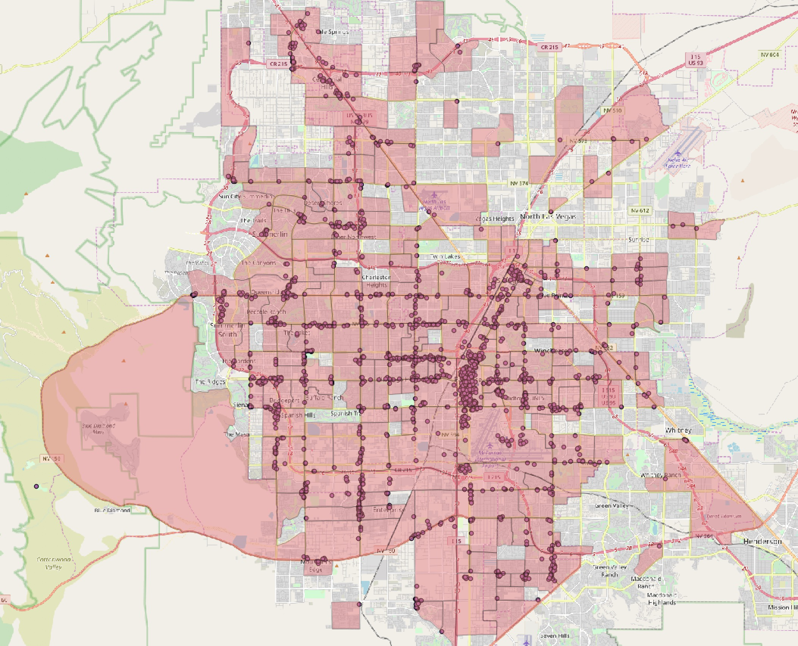

**6. Compute the Statistic Summary for the Review Data on the New Tract Layer**

a. Join the review data with the business location data

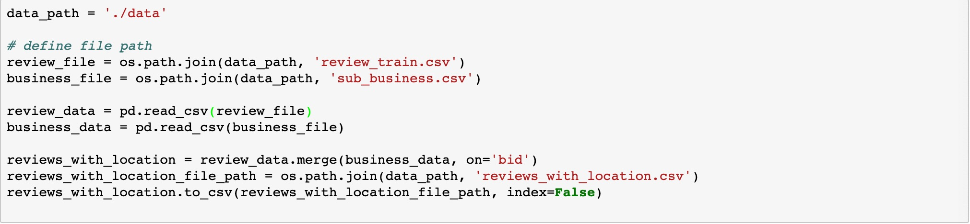

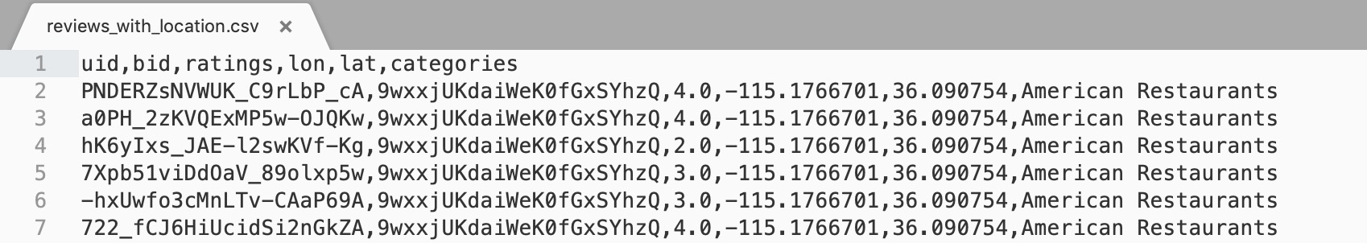

b. Add the review CSV file as the new layer

c. Go to [**Processing**] => [**Toolbox**] => [**Join attributes by location (summary)**]

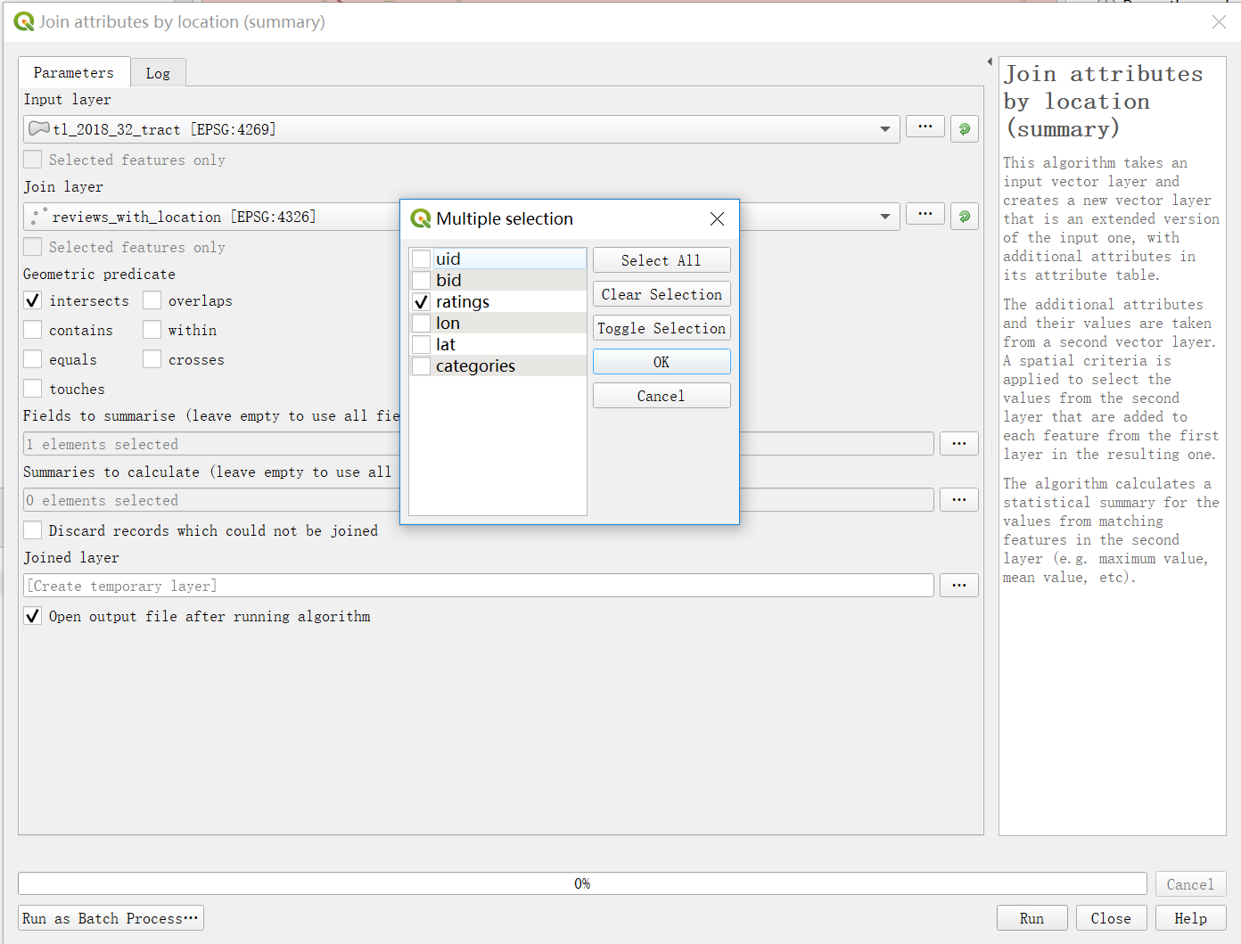

**Choose the attribute to summarize**

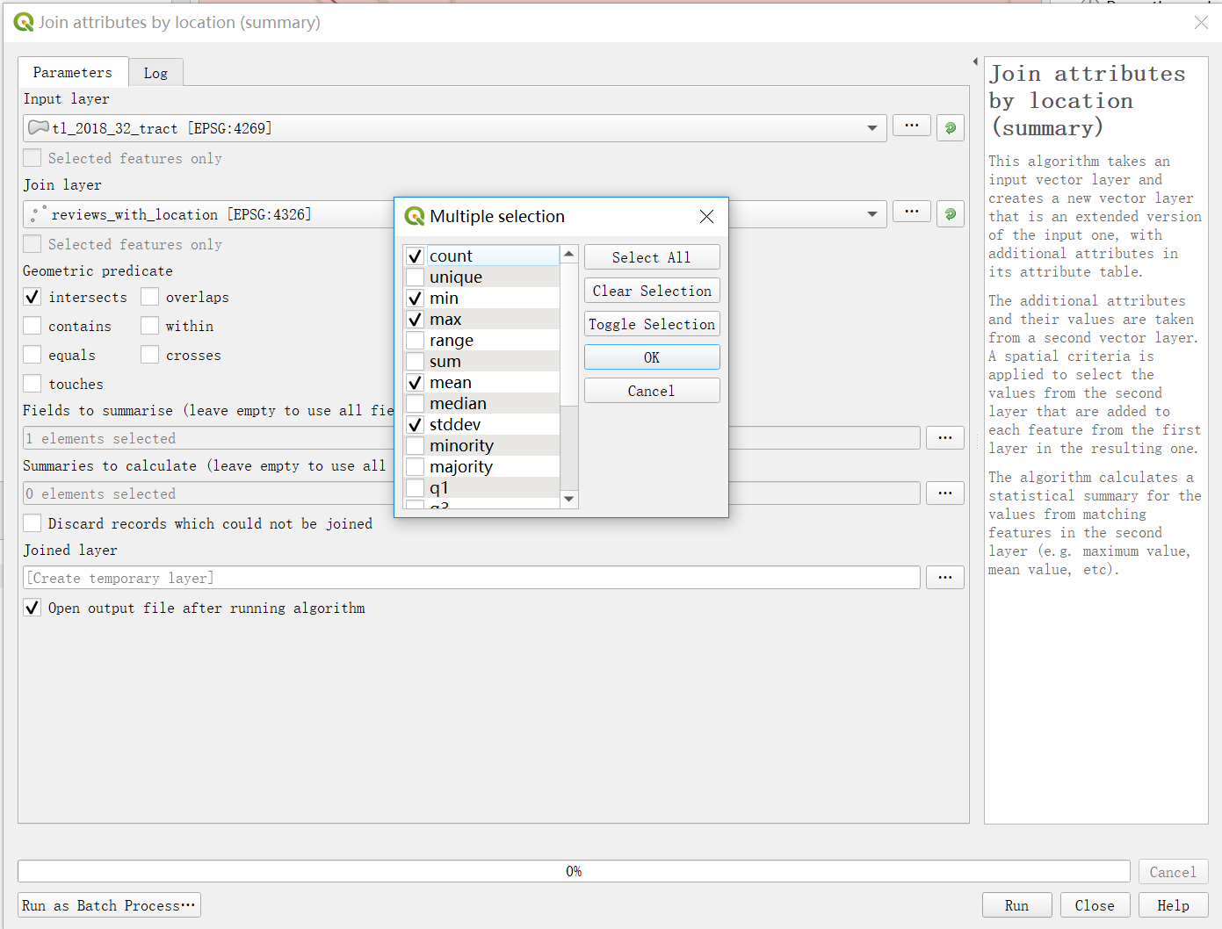

**Choose the statistic method**

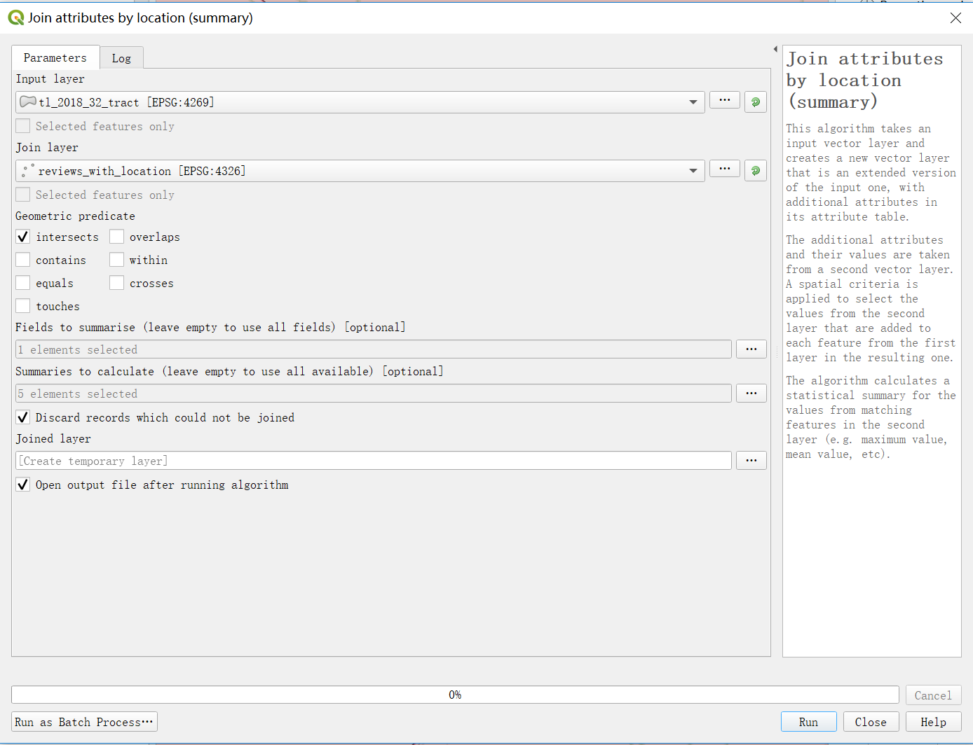

d. Zoom to the joined layer, change the properties, view attribute table

We can see there are more columns related to our required statistic summarizations

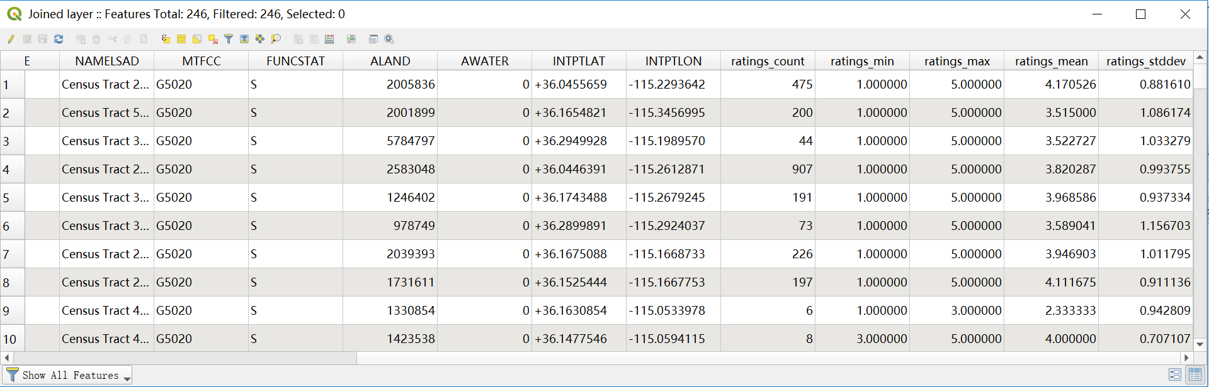

**7. Visualize the statistic results on the map**

Right click the joined layer => [**Properties**] => [**Symbology**]

Change [**No** **Symbol**] to [**Graduated**] and select the column that you what to visualize

You can select any [**mode**] and number of [**Classes**] => click [**classify**]

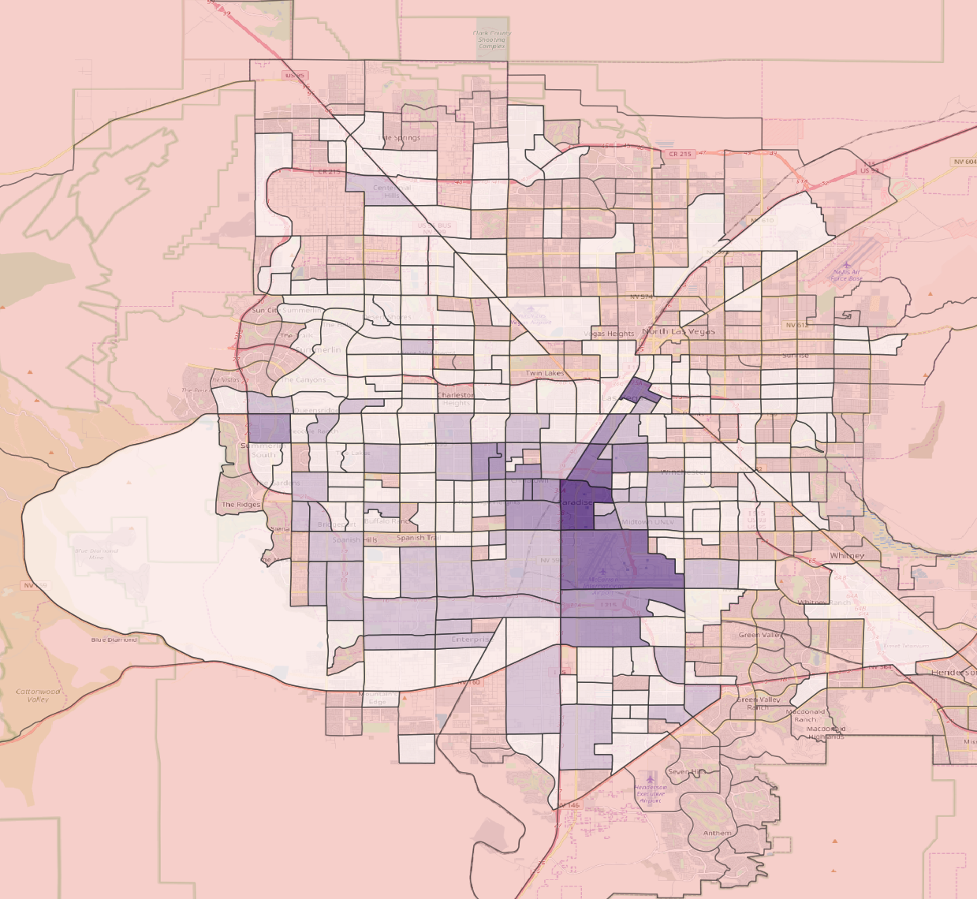

Count of the ratings in each tract

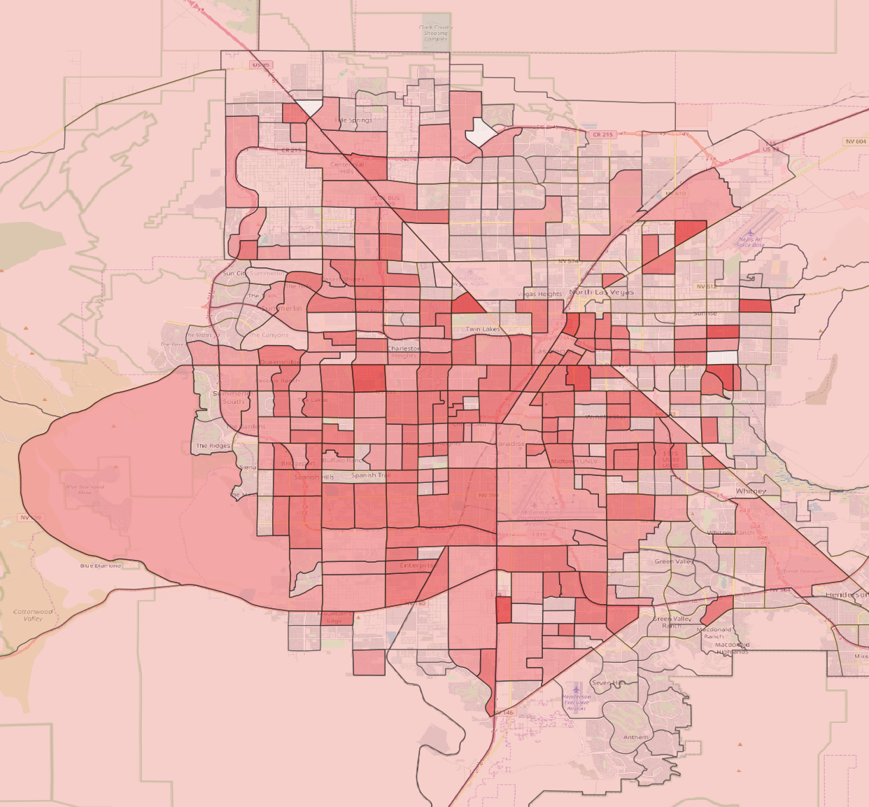

Mean of the ratings in each tract